**Current Architecture:**

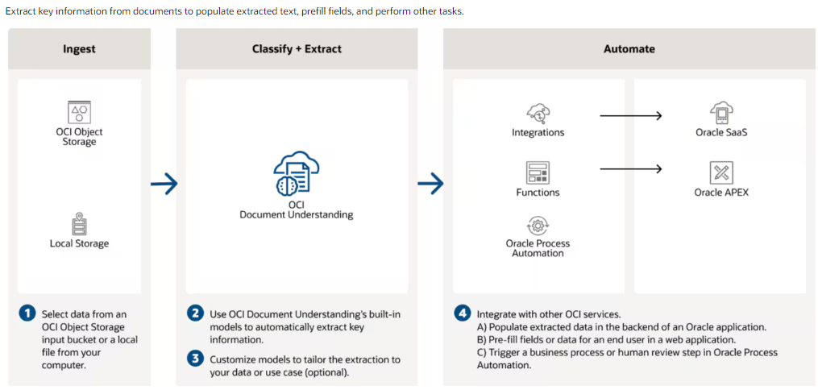

* We currently have an architecture like the one shown in the above picture. The components or services used in the architecture are listed in the table below.

|  |  |
| --- | --- |
| Ingest – to store the files and JSON responses | * OCI Object Storage |
| Classification + Extraction | * OCR – to detect and recognize text in a document * OCI Document Understanding Pre-trained or Custom Models |
| Automate | * OIC Integrations – to populate extracted data * Oracle Base Database with all the security privileges like VPN etc – to store the extracted data * VBCS – to access the feature and display extracted data on the web application |

**Cost Analysis of the current architecture:**

|  |  |
| --- | --- |
| **Object Storage** (Standard) | Free:   * Storage: 10GB per month * Requests: 50000   Paid:   * Storage: **$0.0255** per 1GB post-free 10 GB * Requests: **$0.0034** per 10000 requests post-free 50000 requests |
| OCI – Document Understanding - **OCR** | Free:   * Transactions: 5000 per month   Paid:   * Transactions: **$1** per 1000 transactions post-free 5000 transactions |
| OCI – Document Understanding – **Pre-trained** Document Extraction (Key-Value extraction) | Free:   * Transactions: 5000 per month   Paid:   * Transactions: **$10** per 1000 transactions post-free 5000 transactions |
| OCI – Document Understanding – **Custom** **Training** (Key-Value extraction) | Free:   * Training Hours: 15 hours   Paid:   * Training Hours: **$1.5** per hour post-free 15 hours |
| OCI – Document Understanding – **Custom** Document Extraction (Key-Value extraction) | Free:   * Transactions: 5000 per month   Paid:   * Transactions: **$30** per 1000 transactions post-free 5000 transactions |
| Application Integration – OIC (Standard – License Included) | Paid:   * Standard – License Included (5k messages per message pack) – 1000 Realtime messages(50kb per message) – 100MB File Processing(Total size of files processed per hour) – 1 Message Packs = **$0.65 per hour** |
| Base Database Service - Virtual Machine | Paid:   * Standard – AMD -16GB - 256GB – 1OCPU per Hour = **$0.22 per hour** |
| Base Database Service – Storage – Block Volumes | Paid:   * High Performance - 712GB – 20VPU = **$42.36** |
| Visual Builder Cloud Service | Paid:   * 1 OCPU per Hour = **$1.2365 per hour** |

The lowest charge for the architecture per hour and 1000 paid transactions post usage of free credits is **$86.99**

**List of Pre-trained Models:**

|  |  |
| --- | --- |
| Optical Character Recognition (OCR) | Document Understanding can detect and recognize text in a document. |
| Text extraction | Document Understanding provides the word level and line level text, and the bounding box coordinates of where the text is found. |
| **Key-value extraction** | **Document Understanding extracts a predefined list of key-value pair information from receipts, invoices, passports, and driver IDs.** |
| Table extraction | Document Understanding extracts content in tabular format, maintaining the row and column relationships of cells. |
| Document classification | Document Understanding classifies documents into different types based on visual appearance, high-level features, and extracted keywords. For example, document types such as invoice, receipt, and resume. |
| Optical Character Recognition (OCR) PDF | Document Understanding generates a searchable PDF file in Object Storage. |

**!!Note: Training a document type takes 24 hours.**

**List of Document Types:**

1. **Invoice**
2. **Receipt**
3. Resume
4. Tax Form
5. **Driver License**
6. **Passport**
7. Bank Statement
8. Check
9. Payslip
10. Health Insurance ID

**Key Value feature is supported only for receipt, invoice, passport, and driver license document types.**

**Alternative ways of accessing document understanding:**

Document Understanding can be accessed using the Console, REST API, SDKs, or CLI.

1. Accessing through the Console: Not preferable concerning our objective.
2. REST API: The above architecture is based on this where there will be a need for Database, OIC, and VBCS.

If there is a concern about not using a dedicated Database, OIC, and VBCS. VBS comes with a free price but only if we have a licensed Fusion POD. And there will be a limitation on storage capacity if internal storage of VBS is used to hold data. The Oracle Visual Builder Studio (VBS) has a built-in database with a storage capacity of **5 GB**.

|  |  |  |
| --- | --- | --- |
| **Service Name** | **Current Architecture** | **Alternative API Architecture** |
| File or Response Storage | Oracle Object Storage | Oracle Object Storage |
| Document Understanding | OCR, Pre-trained /Customized Models | OCR, Pre-trained /Customized Models |
| Automate and access over UI | Database, OIC, VBCS | Database(inbuilt or standalone), Fusion POD, VBCS - (all these are subject to research and POC) |

1. Accessing through the SDK: Python is preferable over others concerning our objective.

|  |  |  |
| --- | --- | --- |
| **Service Name** | **Current Architecture** | **Alternative API Architecture** |
| File or Response Storage | Oracle Object Storage | Oracle Object Storage |
| Document Understanding | OCR, Pre-trained /Customized Models | OCR, Pre-trained /Customized Models |
| Automate and access over UI | Database, OIC, VBCS | Python SDK (POC is needed on this to store results in Database, Convert and display results on web page by building it) |

1. Accessing through the CLI: Not preferable concerning our objective.

**!!Note: Alternative ways of accessing document understanding require a POC or research on the components and development as this is predictive architecture.**